Exception Handling is done to avoid errors that occur during the runtime of the program. Hence in such cases, we take care of such exceptions to prevent the program from ending abruptly.
A number of things can give rise to the following kinds of exceptions such as the file not found an error or any type of input type error where the datatype was different than expected or etc. We learn to avoid this and structure our program accordingly in this article.
Let’s look at the following example of exception handling in Java where we use a try-catch statement to handle the exception.
The keyword “try” is used to specify a block where we must place the exception code. A try block must be followed by a catch block, it means that we cannot use the try block alone.
The “catch” block is used to handle the exception, it must be preceded by the try block. It means that we cannot use the catch block alone.
If you have to perform different tasks in the appearance of different exceptions, use the Java multiple catch block.
Let’s see a simple example of the Java multiple catch block.
In the following program, the first catch block was executed because the code we wrote in the try block throws ArithmeticException (because we divided the number by zero).
Example 1:
public class App {
public static void main(String[] args) {
int x = 0;
try{
System.out.println("We don't know, what will be the outcome "+x/0);
}catch (ArithmeticException e) {
System.out.println("Arithmetic Exception occurred");
}catch (Exception e) {
System.out.println("Inside exception block");
}
}
}
Output: Arithmetic Exception occurred
This also explains the concept of a hierarchy of exception classes. This hierarchy, if it is not maintained, can be transformed into the code being unreachable at some points.
In the following code if the Exception catch block appears before the Arithmetic Exception Block then the latter will become unreachable as the Exception will catch all the thrown exceptions.
All catch blocks should be ordered from the most specific to the most general. The catch for ArithmeticException must come before the catch for Exception.
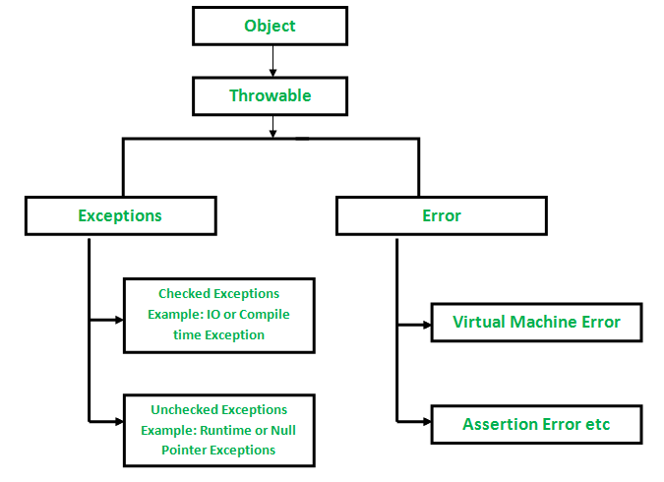
Finally block
The finally block is the block which always gets executed no matter the programs throws an exception or not. But we have to follow some basic conditions that the catch blocks always is after the throw block.
This could be used to execute an important segment of code we always want the compiler to execute no matter what is the state of the exception.
Example 2:
public class App {
public static void main(String[] args) {
int x = 2;
try{
System.out.println("We don't know, what will be the outcome "+x/2);
}catch(RuntimeException e){
System.out.println("Runtime exception");
}catch(Exception e){
System.out.println("Exception!!!");
}
finally{
System.out.println("This will be get printed");
System.out.println();
}
}
}
Output:
We don’t know, what will be the outcome 1
This will be get printed
Throw and Throws:
Throws are used to suppress the error if the user doesn’t want to specify the try and catch block. Note that this doesn’t handle the error only suppresses it. It should be used only when the developer is sure that the error doesn’t occur.
The throw is used to forcefully throw an error where it is decided by the developer regarding the certain conditions.
Example 3:
public class App {
public static void main(String[] args) {
try {
someMethod();
} catch (FileNotFoundException e) {
System.out.println("catch block of main method");
}
}
public static void someMethod() throws FileNotFoundException {
System.out.println("Message from someMethod");
throw new FileNotFoundException();
}
}
Output:
Message from someMethod
catch block of the main method
The keyword “throw” is used to throw an exception from any method or static block, while the keyword “throws”, used in a method declaration, indicates what exception can be thrown with this method. They are not interchangeable.
In a program, if there is a possibility that an exception occurs, the compiler always warns us and we must handle that checked exception. Otherwise, we will get a compile-time error.
To avoid this compile-time error, we can handle the exception in two ways:
- By using try catch block
- By using throws keyword
Example 4:
import java.io.FileNotFoundException;
import java.io.FileReader;
public class App {
public static void main(String[] args) {
someMethod();
}
public static void someMethod() {
try {
FileReader in = new FileReader("file.txt");
} catch (FileNotFoundException e) {
System.out.println("message from catch block");
}
System.out.println("Message from someMethod");
}
}
Output
message from catch block
Message from someMethod
We can use the keyword throws to delegate the responsibility of handling exceptions to the caller, then the caller method is responsible for handling that exception.
public static void main(String[] args) throws FileNotFoundException {
someMethod();
}
public static void someMethod() throws FileNotFoundException {
FileReader in = new FileReader("file.txt");
System.out.println("Message from someMethod");
}
Output: Runtime error
Example 5:
public class Test {
public static void main(String[] args) {
Object x = Integer.valueOf(2);
try {
System.out.println((Integer) x);
System.out.println((String) x);// throw ClassCastException
} catch (ClassCastException e) {
System.out.println(e.getClass());
}
}
}
Example 6:
import java.io.File;
import java.io.IOException;
class Calculate {
void a() throws IOException {
File f = new File("a.txt");
f.createNewFile();
}
void b() throws IOException {
a();
}
void c() throws IOException {
b();
}
void d() {
try {
c();
} catch (IOException e) {
System.out.println(e.getMessage());
}
}
}
public class MainTest {
public static void main(String args[]) {
System.out.println("start main");
new Calculate().d();
System.out.println("end main");
}
}

